**User Guidelines**

Step 1:

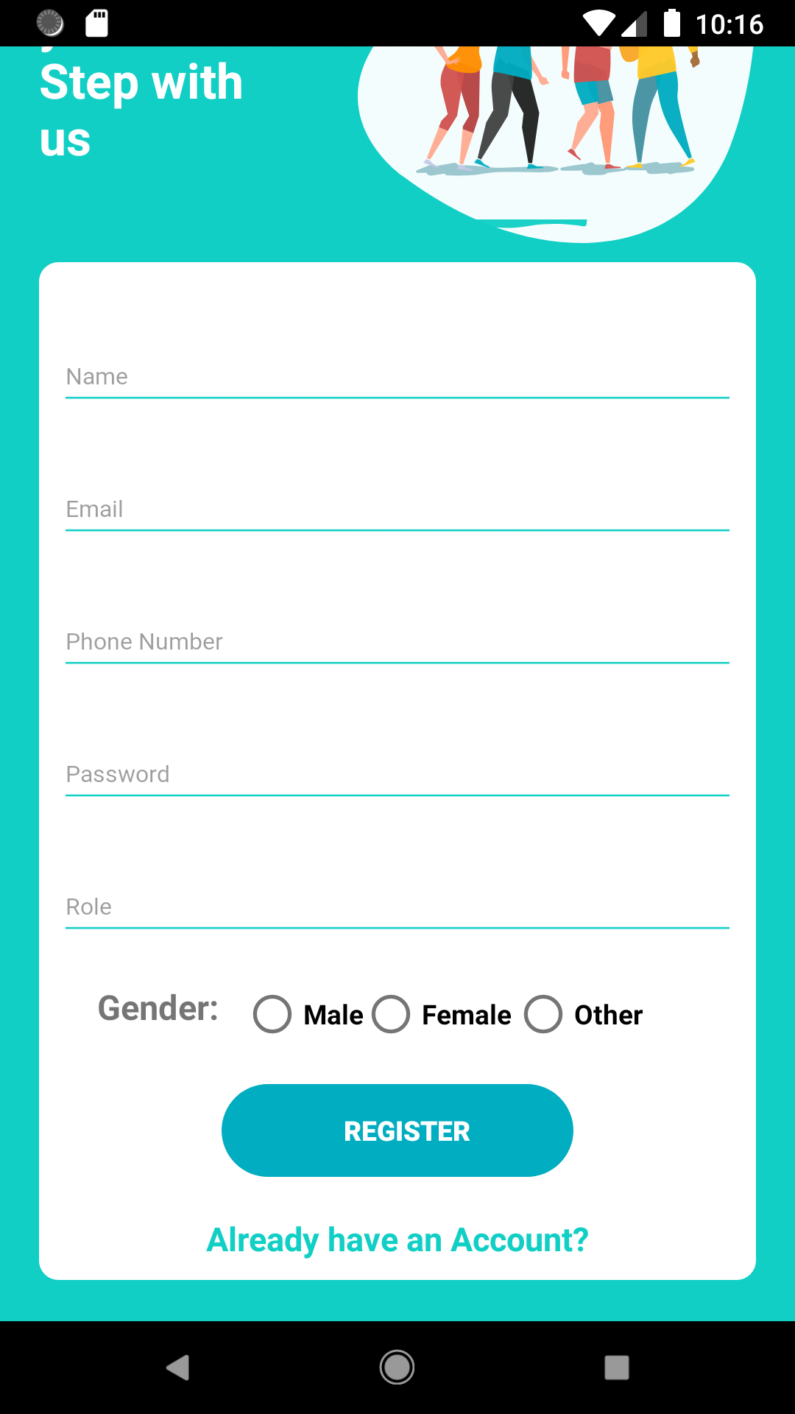

Create an Account using Name, Email, Password, Phone Number, Role and Gender.

Step 2:

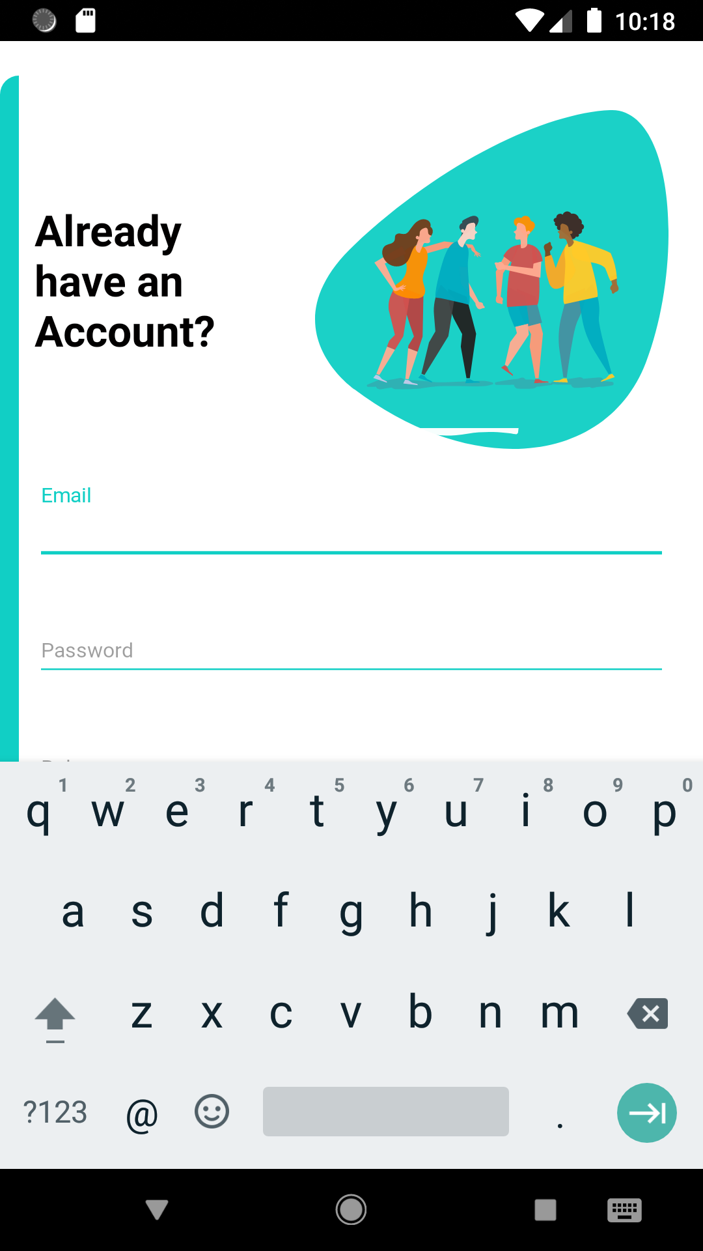

Login using the email, password and role that you have used to register into the account.

Step 3:

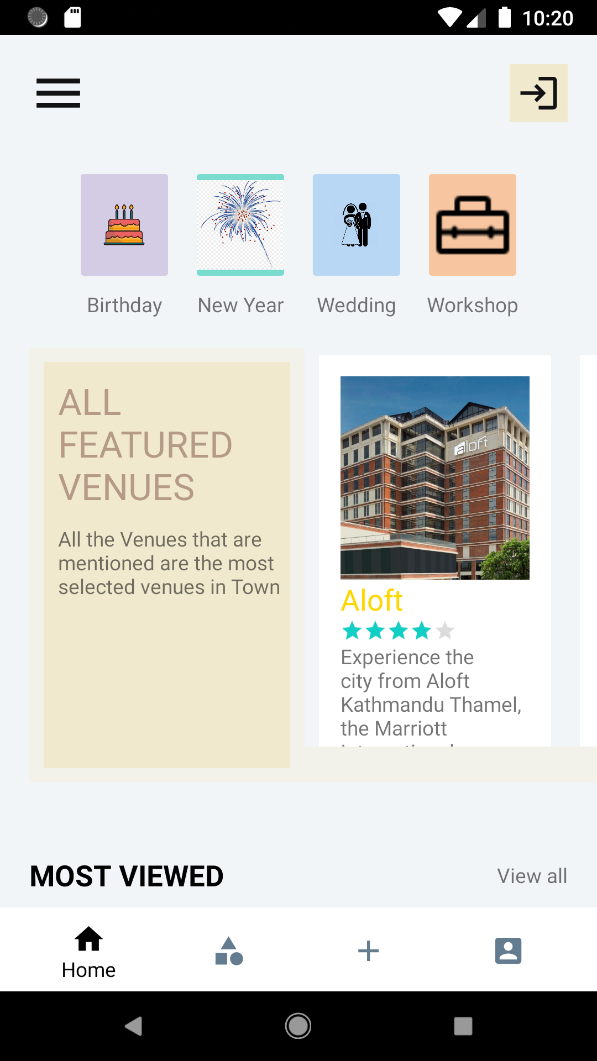

After login in, the home page should be visible. The user can use the navigation bar to go the designated page he/she wants to go to.

Step 4:

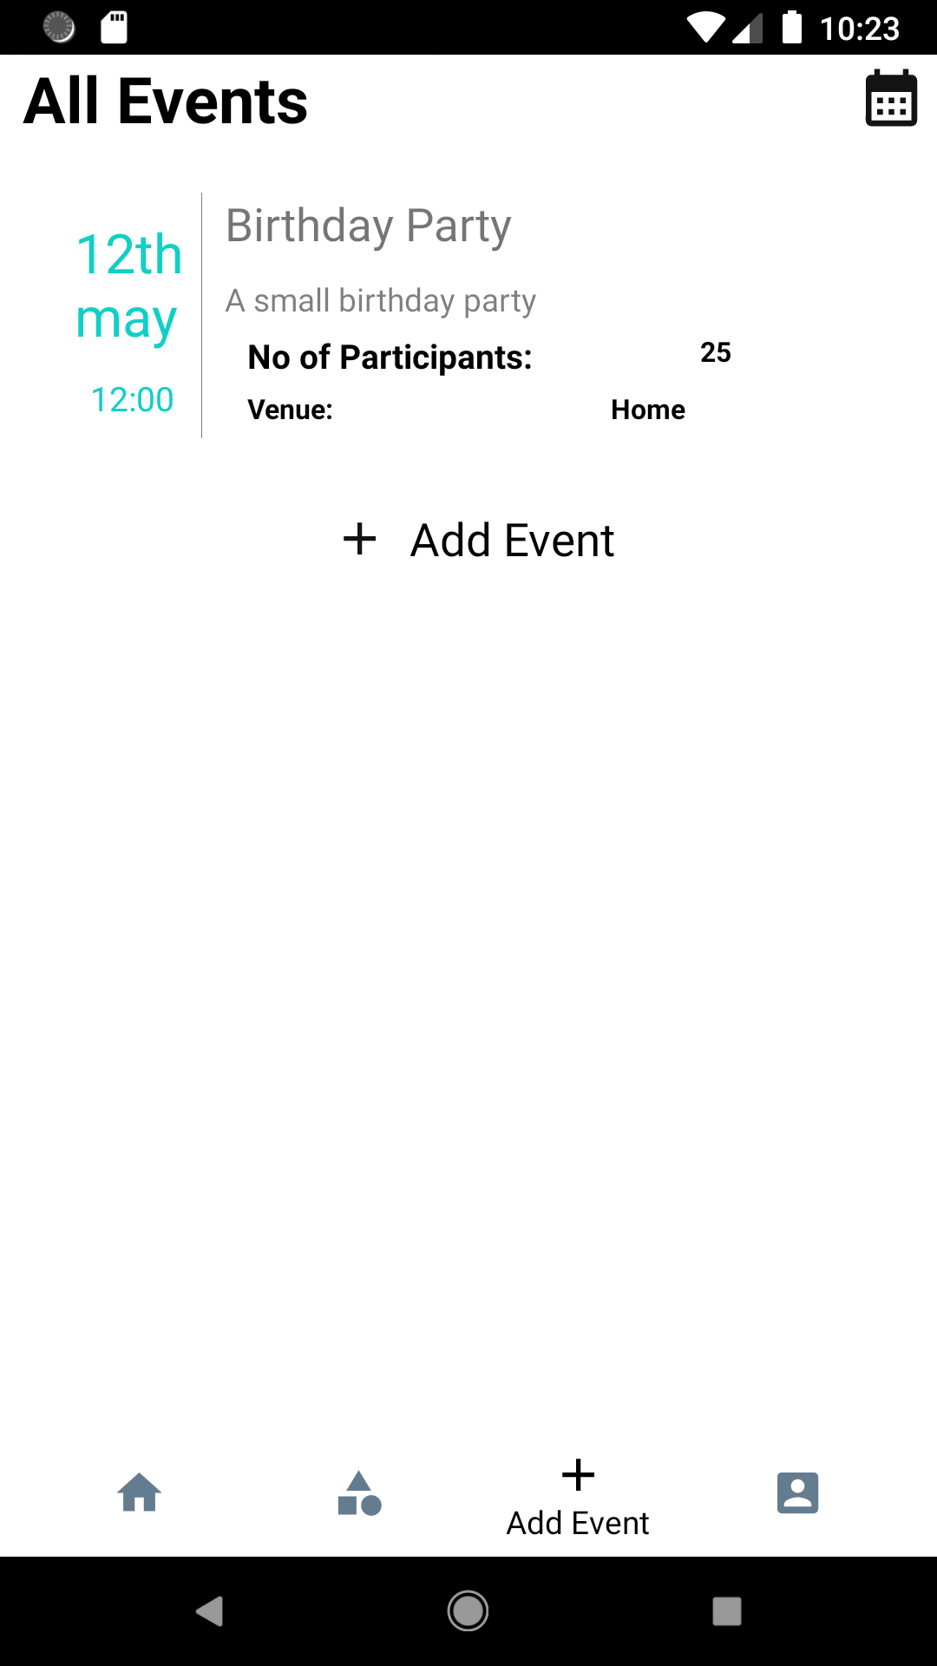

The Add Event should display the above view, as shown in the above image, the page will contain the events that the user has added. Furthermore, the user can add more events using the ‘Add Event’ button.

Step 5:

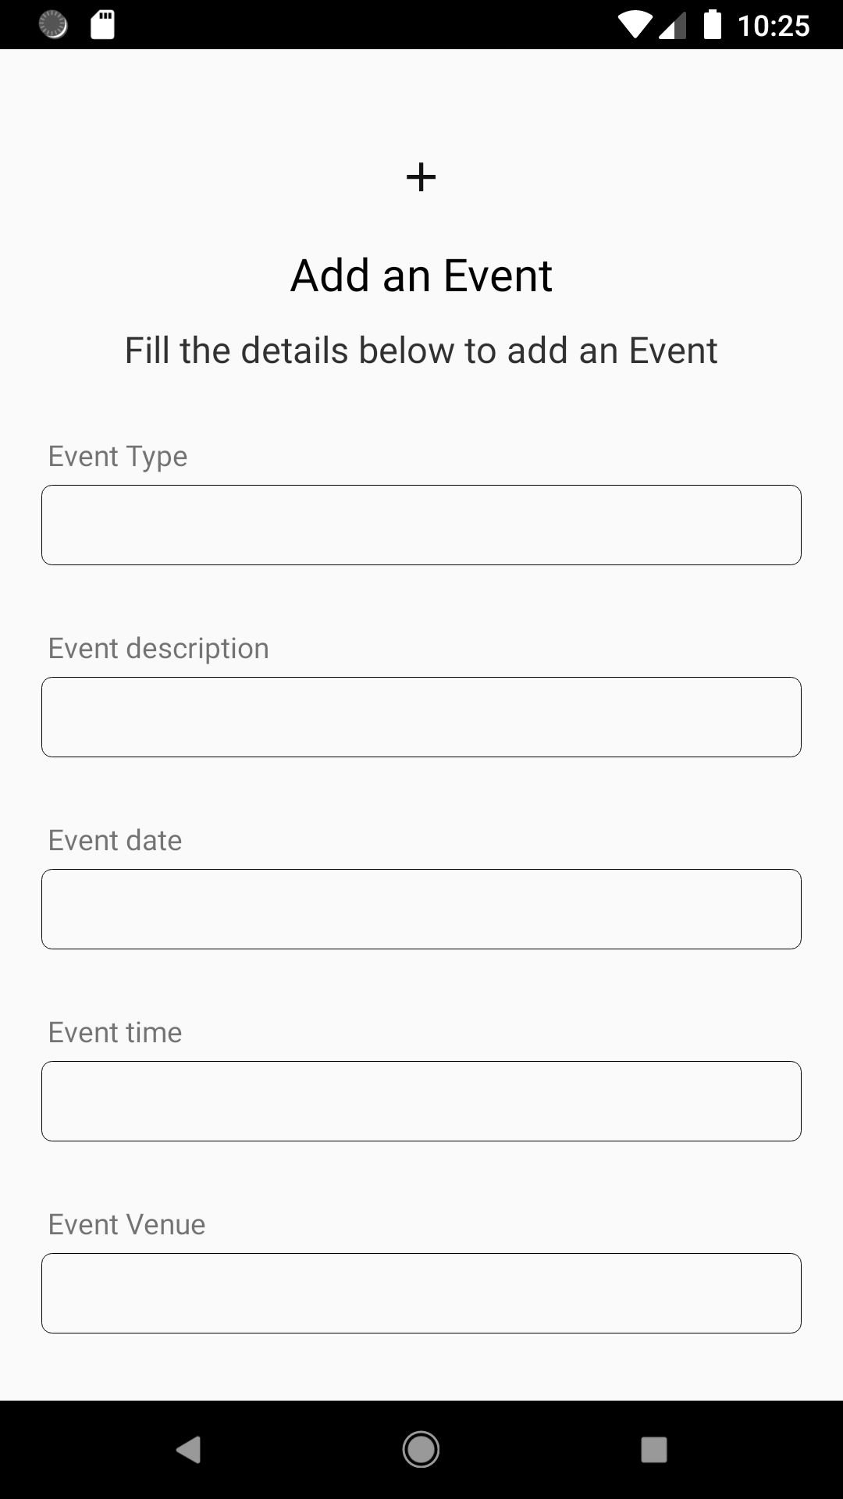

The ‘Add Event’ button will lead to this page where the user can add the event he/she wants to.

Step 6:

After adding the recently added event would be shown in the Event List Page

Step 7:

User can use the Sign Out button if he/she wises to sign out.